United Farmers Free Access (FA) Minerals
Updated December 2015 (12 months shelf life required at indicated levels)

FREE ACCESS MINERALS ARE IN A GREEN BAG
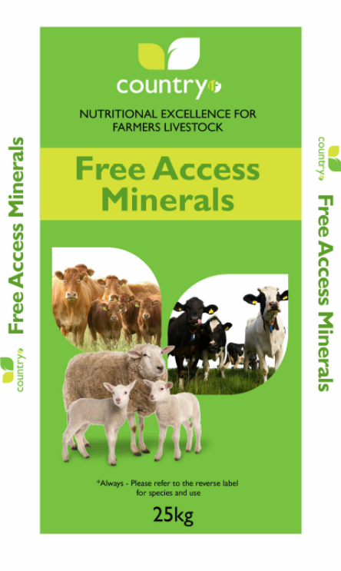
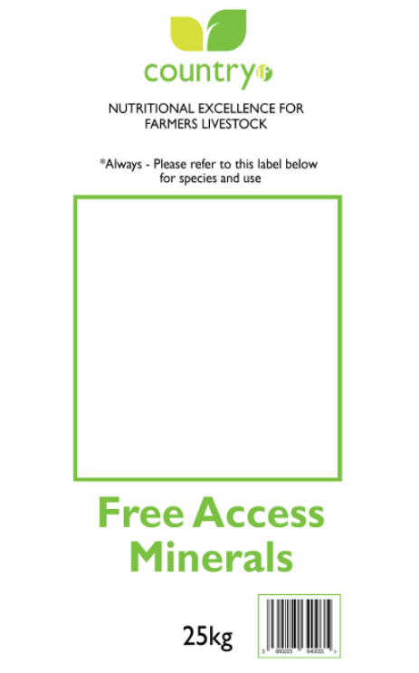

BACK LABEL COLOURS

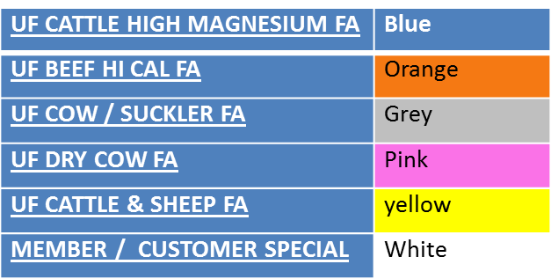

FREE ACCESS MINERALS PRODUCT SPECIFICATIONS

UF CATTLE HIGH MAGNESIUM FA (BLUE LABEL)

Vitamin A | iu/kg | 500000.000
Vitamin D3 | iu/kg | 100000.000
Vitamin E | mg/kg | 1000.000
Vitamin B12 | mcg/kg | 1000.000
Copper as Sulphate | mg/kg | 2000.000
Manganese as Oxide | mg/kg | 2000.120
Cobalt | mg/kg | 80.000
Zinc as Oxide | mg/kg | 5999.760
Iodine as Iodate | mg/kg | 200.025
Selenium as Selenite | mg/kg | 25.020
Calcium | % | 10.839
Phosphorus | % | 0.002
Sulphur (T) | % | 0.104
Sodium | % | 8.001
Salt | % | 20.345
Chloride | % | 12.349
Magnesium | % | 25.007
Protein | % | 0.226
Ash | % | 94.665
Acid Insoluble Ash | % | 3.003

UF BEEF HI CAL FA (ORANGE LABEL)

Vitamin A | iu/kg | 500000.000
Vitamin D3 | iu/kg | 100000.000
Vitamin E | mg/kg | 1500.000
Vitamin B12 | mcg/kg | 1000.000
Copper as Sulphate | mg/kg | 2000.000
Manganese as Oxide | mg/kg | 2000.120
Cobalt | mg/kg | 80.000
Zinc as Oxide | mg/kg | 4000.320
Iodine as Iodate | mg/kg | 200.025
Selenium as Selenite | mg/kg | 25.020
Calcium | % | 28.155
Phosphorus | % | 1.000
Sulphur (T) | % | 0.104
Sodium | % | 8.000
Salt | % | 20.352
Chloride | % | 12.354
Magnesium | % | 0.112
Protein | % | 0.076
Ash | % | 95.404
Acid Insoluble Ash | % | 0.187

UF COW/SUCKLER FA (GREY LABEL)

Vitamin A | iu/kg | 500000.000
Vitamin D3 | iu/kg | 100000.000
Vitamin E | mg/kg | 2000.000
Vitamin B12 | mcg/kg | 1000.000
Copper as Sulphate | mg/kg | 2000.000
Manganese as Oxide | mg/kg | 4000.240
Cobalt | mg/kg | 80.000
Zinc as Oxide | mg/kg | 4999.680
Iodine as Iodate | mg/kg | 299.720
Selenium as Selenite | mg/kg | 25.020
Calcium | % | 19.955
Phosphorus | % | 4.000
Sulphur (T) | % | 0.104
Sodium | % | 8.001
Salt | % | 20.345
Chloride | % | 12.372
Magnesium | % | 6.007
Protein | % | 0.226
Ash | % | 90.989
Acid Insoluble Ash | % | 0.867

UF DRY COW FA (PINK LABEL)

Vitamin A | iu/kg | 700000.000
Vitamin D3 | iu/kg | 150000.000
Vitamin E | mg/kg | 8000.000
Vitamin B12 | mcg/kg | 1000.000
Copper as Sulphate | mg/kg | 2000.000
Copper as MAAC | mg/kg | 500.000
Manganese as Oxide | mg/kg | 6000.000
Cobalt | mg/kg | 80.000
Zinc as Oxide | mg/kg | 6000.000
Iodine as Iodate | mg/kg | 450.000
Selenium as Selenite | mg/kg | 35.000
Potassium | % | 0.113
Calcium | % | 2.000
Phosphorus | % | 7.000
Sulphur (T) | % | 0.111
Sodium | % | 13.000
Salt | % | 33.063
Chloride | % | 20.113
Magnesium | % | 15.000
Oil | % | 0.763
Ash | % | 84.392
Fibre | % | 0.286
Protein | % | 0.892
Acid Insoluble Ash | % | 0.719

UF CATTLE & SHEEP FA (YELLOW LABEL)

Vitamin A | iu/kg | 500000.000
Vitamin D3 | iu/kg | 100000.000
Vitamin E | mg/kg | 1500.000
Vitamin B12 | mcg//kg | 1000.000
Manganese as Oxide | mg/kg | 4000.240
Cobalt | mg/kg | 80.000
Zinc as Oxide | mg/kg | 5999.760
Iodine as Iodate | mg/kg | 200.025
Selenium as Selenite | mg/kg | 25.020
Calcium | % | 22.890
Phosphorus | % | 2.000
Sodium | % | 8.001
Salt | % | 20.345
Chloride | % | 12.361
Magnesium | % | 5.007
Protein | % | 0.226
Ash | % | 92.720
Acid Insoluble Ash | % | 0.764

United Farmers In Feed – “Mix It” Minerals
Updated December 2015 (9 months shelf life required at indicated levels)

IN FEED MINERALS ARE IN A BLUE BAG

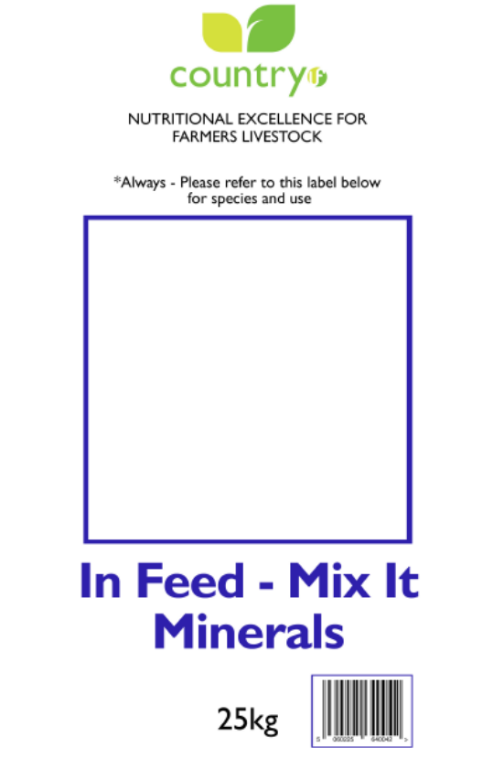
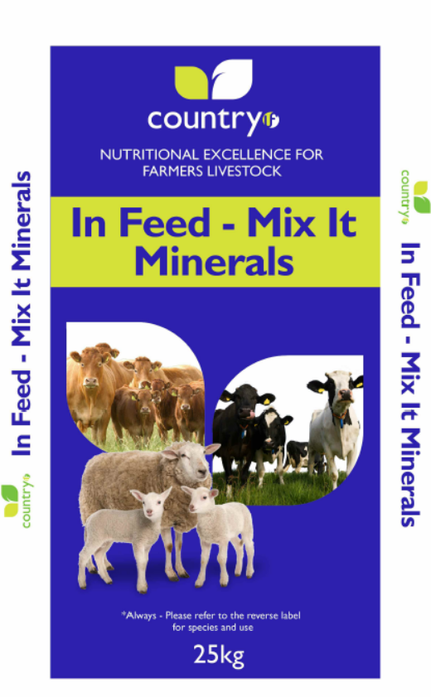

BACK LABEL COLOURS

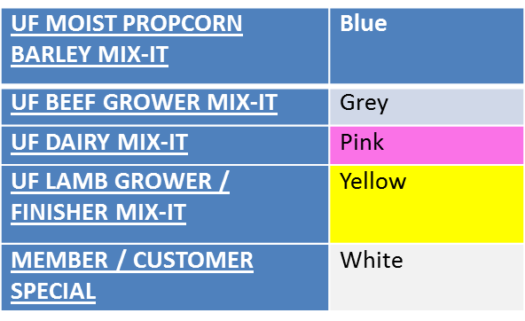

IN FEED MINERALS PRODUCT SPECIFICATIONS

UF MOIST PROPCORN BARLEY MIX-IT (BLUE LABEL)

Vitamin A | iu/kg | 400000.000
Vitamin D3 | iu/kg | 100000.000
Vitamin E | mg/kg | 3000.000
Vitamin B12 | mcg/kg | 1000.000
Copper as Sulphate | mg/kg | 2000.000
Manganese as Oxide | mg/kg | 3000.000
Cobalt | mg/kg | 60.000
Zinc as Oxide | mg/kg | 3000.000
Iodine as Iodate | mg/kg | 300.00
Selenium as Selenite | mg/kg | 30.000
Calcium | % | 25.354
Phosphorus | % | 2.000
Sulphur (T) | % | 0.104
Sodium | % | 8.000
Salt | % | 20.348
Chloride | % | 12.363
Magnesium | % | 3.000
Protein | % | 0.076
Ash | % | 95.398
Acid Insoluble Ash | % | 0.473

UF BEEF GROWER MIX-IT (GREY LABEL)

Vitamin A | iu/kg | 220000.000
Vitamin D3 | iu/kg | 60000.000
Vitamin E | mg/kg | 1000.000
Vitamin B12 | mcg/kg | 1000.000
Copper as Sulphate | mg/kg | 1200.000
Manganese as Oxide | mg/kg | 2000.120
Cobalt | mg/kg | 80.000
Zinc as Oxide | mg/kg | 2000.160
Iodine as Iodate | mg/kg | 179.705
Selenium as Selenite | mg/kg | 14.985
Calcium | % | 28.747
Phosphorus | % | 0.001
Sulphur (T) | % | 0.062
Sodium | % | 9.001
Salt | % | 22.897
Chloride | % | 13.898
Magnesium | % | 0.086
Protein | % | 0.075
Ash | % | 97.094
Acid Insoluble Ash | % | 0.149

UF DAIRY MIX-IT (PINK LABEL)

Vitamin A | iu/kg | 400000.000
Vitamin D3 | iu/kg | 80000.000
Vitamin E | mg/kg | 2500.000
Vitamin B12 | mcg/kg | 1000.000
Copper as Sulphate | mg/kg | 2000.000
Manganese as Oxide | mg/kg | 2000.000
Cobalt | mg/kg | 80.000
Zinc as Oxide | mg/kg | 6000.000
Iodine as Iodate | mg/kg | 400.000
Selenium as Selenite | mg/kg | 30.000
Calcium | % | 16.953
Phosphorus | % | 6.000
Sulphur (T) | % | 0.104
Sodium | % | 9.000
Salt | % | 22.897
Chloride | % | 13.948
Potassium | % | 0.037
Magnesium | % | 8.000
Protein | % | 0.076
Ash | % | 92.526
Acid Insoluble Ash | % | 1.048

UF LAMB GROWER/FINISHER MIX-IT (YELLOW LABEL)

Vitamin A | iu/kg | 220000.000
Vitamin D3 | iu/kg | 60000.000
Vitamin E | mg/kg | 1200.000
Vitamin B12 | mcg/kg | 1500.000
Manganese as Oxide | mg/kg | 2000.000
Cobalt | mg/kg | 60.000
Zinc as Oxide | mg/kg | 2000.000
Iodine as Iodate | mg/kg | 180.000
Selenium as Selenite | mg/kg | 15.000
Ammonium Chloride | % | 10.000
Calcium | % | 26.039
Sodium | % | 8.000
Salt | % | 20.354
Chloride | % | 18.955
Magnesium | % | 0.080
Protein | % | 16.300
Ash | % | 94.004
Acid Insoluble Ash | % | 0.132

